USING THE PID CONTROLLER APPLIED IN PUMPING SYSTEMS DIRECT
USANDO EL CONTROL PID APLICADO EN EL SISTEMA DE BOMBEO DIRECTO

Lais Régis Salvino¹, Kamilla Henrique Mendonça², Anne Caroline Linhares Monteiro³, Heber Pimentel Gomes⁴ and Saul de Tarsus Marques Bezerra⁵
Federal University of Paraíba, Campus I, Cidade Universitária, ZIP CODE: 58051-900. João Pessoa, Paraíba, Brasil. 1- lais_regis@hotmail.com, +55 083 987072551. 2- kamillapdm@hotmail.com, +55 083 987438023. 3 - anneclmonteiro@hotmail.com, +55 083 987974088. 4 - heberp@uol.com.br, +55 083 988692300. 5 Federal University of Pernambuco, Academic Center of the Agreste, s.bezerra@hotmail.com

RESÚMEN. Con la densidad de población en las últimas décadas, los sistemas de abastecimiento de agua tienen sufrido cambios en su patrón de consumo. Estos cambios requieren esfuerzos por parte de las empresas a nivel técnico y hacer hincapié en la necesidad de estrategias orientadas a la eficiencia operativa del sistema. La gestión a través de los controles automáticos comprende un mecanismo robusto para medir estos resultados. Este trabajo presenta un estudio comparativo de los parámetros hidráulicos y eléctricos de una red experimental automatizado. El comportamiento del sistema se analizó bajo dos condiciones: sin el uso de el controlador y el controlador proporcional, integral y derivativo (PID). Los resultados mostraron la eficacia del controlador utilizado para el consumo diferentes escenarios. Con respecto a la eficiencia energética se verificó, según el cálculo del consumo específico de energía (CE), el ahorro de electricidad de uso del controlador.
ABSTRACT. The rapid growth in the population over the last few decades has resulted in changes of supply system consumption patterns. Such, require effort from the companies in technical aspects; targeting the need of strategies to improve operational efficiency. The management system, based on automated control, carrys a strong mechanism to gauge these results. It is the purpose of this paper to present a Comparative study of both hydraulic and electric parameters of an experimental automated network. The network behavior was analyzed under two conditions: without the use of the controller and with the Proportional-Integral -Derivative (PID) controller. The results indicated the efficiency of the applied controller in different consumption scenarios. Dealing with the energy efficiency, it was verified that, according to calculations related to the Specific Energy Consumption (SEC), the reduction on the electrical energy is notable with the use of the controller.

Key words: Power Efficiency, Supply System, PID Controller.
Palabras Llaves: Eficiencia Energética, Sistemas de Abastecimiento, Controlador PID.
INTRODUCTION

The intense process of urbanization that occurred in the last decades has required major efforts in the technical, organizational and financial scopes by the sanitation companies, once the water distribution systems are increasingly larger and more complex, resulting in high costs of production of treated water and electrical power (Camboim, 2012).
The water supply and sewerage systems are responsible for about 3% of the world energy consumption and 90% of this portion is the responsibility of the pumping equipment (Gomes and Carvalho, 2012). According to Ramos et al. (2012), this consumption can be diminished by at least 25% through improvements in energy efficiency of the water supply system. In this way, measures that define operational strategies for hydraulic and energy efficiency are essential in the current scenario.
The service pressure control is one of the basic actions for the reduction of energy consumption in urban water distribution systems. According to Carvalho (2012), excessive pressure on the water supply network unnecessarily enhances costs and causes malfunctions in pipes and accessories and also reduces equipment lifespan.
The implementation of automated systems presents itself as a robust mechanism of operational management in real time. It enables the accurate control and the improvement of operating performance. Thus, the use of frequency inverter coupled to automatic control systems ensures the more efficient and accurate operation of the water supply network.
The use of frequency inverters allows varying the engine rotation speed keeping the pump operation at minimum levels of power that are sufficient to fully meet the demands. This ensures the piezometric control of water network, energy savings, increase system reliability and extension of service life of pumping stations.
The water distribution systems work with various parameters and according to varied conditions of supply, which makes difficult to do a purely mechanical or manual monitoring. For a skillful management of these systems, it is necessary to have an efficient process for the acquisition, storage and transmission of electrical and hydraulic quantities. Thus, in view of the technological advancement, it has been invested in automation to achieve these goals.
The use of robust algorithms is a very effective tool in industrial automation and it could be also applied on a water supply network after make some adaptations. In automation phase of a system, programmable controllers are used.
The PID controller is the most used in feedback control systems. This is justified by its easy implementation in addition to the low cost, robustness and versatility. This control technique is able to provide transient behavior and permanent regime, both satisfactory for a wide variety of procedures found in the industry, which consequently promotes the diversity of applications in control systems (Campestrini, 2006).
Quadros and Pinto (2013) discussed about the control of pressures in water supply systems by using the Pressure Reducing Valves (PRVs). The fluctuations in the operating pressures in the distribution networks were filtered by the PID control system with automatic tuning. Simulations have demonstrated the applicability of the proposed methods since all the performance indicators of the system managed by PID controllers were improved comparing to the water network performance with manual control.
The objective of this study was to simulate the operation of a water supply network in low pressure zone and compare the hydraulic and electrical parameters obtained with and without the action of a controller. The control methodology adopted was the PID (Proportional Integral Derivative) in its conventional form, which consists of the sum of three terms: a term proportional to the error, a term proportional to the integral of the error and a term proportional to the derivative of the error (Negri, 2004).

MATERIALS AND METHODS

The Automated System of Water Distribution (ASWD) is an experimental pressurized bench that simulates a water supply system located in the Laboratory of Energy and Hydraulics Efficiency in Sanitation in the Federal University of Paraiba – LENHS/UFPB (Figure I).
At first, the scope of the ASWD is to simulate a water distribution system sectored in two consumption zones (low zone and high zone) whose discharge extensions have markedly distinct topographic quotas. However, for the purposes suggested in this work, an isolated analysis of the lower area is sufficient. It is understood by low zone the entire section (without branches) from the supply reservoir (RNF) until the discharge branch RD-1 (Figure II).
The pump station of this system consists of a 3 horsepower motor pump set (CMB) with three-phase induction motor (220/380V). The activation of the CMB is performed through a frequency converter/inverter. It allows to maintain the operating pressures at pre-established and constant levels when associated with an automatic control system, adjusting the operation of the pump station to the frequent variations in demand that occur occasionally. This way, it will be possible to avoid overpressure and unnecessary energy costs.
Throughout the water network are arranged three pressure transducers (PT-1, PT-2 and PT-3) and a transducer flow (FT-1) in order to monitor, respectively, the pressure and flow of network service. In this work, the dynamic pressure at the point of operation of the transducer PT-3 was chosen as a monitoring and control reference.
There are two proportional valves to operate on the network causing the necessary interference in hydraulic parameters. The CV-2 valve is located near the discharge branch and it aims to emulate the flow variation demanded by changing the degree of closure. For this purpose were idealized seven consumption ranges interspersed 5º in 5º between the range of 30º (maximum consumption) and 60º (minimum consumption). The CV-1 valve is located at the entrance of consumption zone and it has been used with a fixed degree of 20º generating a located head loss purposely. The intervention on the closure degree of this valve was required to meet the operational limitations of the motor pump set whose maximum permissible power is 2.53 kW; this value corresponds to the product of motor service factor and the available engine power rating.
The reading of the hydraulic parameters provided by sensors and actuators, and the execution of command actions on the proportional valves and frequency converter are possible because the communication is established between the data acquisition board from National Instruments and the software LabVIEW®.
The water supply and discharge of this experimental bench are carried out by 310 L fiber glass tanks interconnected with each other.
CONTROLLER PROPORTIONAL, INTEGRAL, AND DERIVATIVE (PID)

It was implemented a conventional PID controller in the system to obtain the rotation speed control of the motor pump set used in the experimental bench (ASWD). This type of control was chosen because of its operational ease and low cost in addition to being one of the most utilized in industry, occupying a range between 90% and 95% (Aström and Hägglund, 1995).
The PID controller is composed by three parts: Proportional, Integral, and Derivative. The sum of these terms generates the output signal $u\left(t\right)$ , which acts to control the speed of rotation of the motor pump set. Figure III shows a schematic illustration of the PID controller.
Each part is distinguished by a different function in the performance of the PID controller. The proportional term provides a relationship between the error $e\left(t\right)$ and the constant of proportional gain $\text{Kp}$, then the controller output is proportional to the value of actual error. It acts in transient response of the system by reducing the rise time, in addition to reduce the permanent regime error. The term Integrative consists of multiplying the constant of integral gain$\text{Ki}$and the integral of the error signal. $e\left(t\right)$. The use of this term eliminates the error in permanent regime that is generated by the action of proportional control, but can also affect the transient response of the system. The derivative term is responsible for reducing the magnitude of overshooting caused by integrative part and also by increasing the system stability, improving the transient response (HAFFNER, 2013). The control action of Derivative part is proportional to the rate of change of the error signal over time and the variable of derivative gain $\text{Kd}$ (Aström and Wittenmark, 1995).
Second BÖHM (2005), the PID control low in the time domain can be described mathematically by Equation (1),

$u(t)=\text{Kp}\left[e(t)+\frac{1}{\text{Ki}}\int{e(t)\text{dt}+\text{Kd}\frac{\text{de}(t)}{\text{dt}}}\right]$ (1)

Where $e\left(t\right)$ represents the difference between the reference input and the output variable of the system. This error signal is the input variable of the controller, and the output signal of the controller is given by the variable $u\left(t\right)$. However, to get a digital version of the PID controller, it was necessary to discretize the integral and derivatives components. The simplest way to discretize an integral is bringing it to a sum, reaching the used form of the controller on the digital version for implementation in LabVIEW®, according to Equation (2).

$u(k)=K_{p}\left\{e(k)+\frac{T_{0}}{K_{i}}\left[\frac{e(0)+e(k)}{2}+\sum_{i=1}^{k−1}{e(i)}\right]+\frac{K_{d}}{T_{0}}\left[e(k)−e(k−1)\right]\right\}$ (2)

It was found through tests performed with the controller in ASWD experimental bench that the gains that ensured the greatest synchronism of the control parameters were: 0.1 for Kp; 0.2 for Ki and 0.03 for Kd. It was used the sample time of 150 ms to collect data.
In order to test the PID controller efficiency were simulated situations of variation in the system demand. To emulate this scenario of operation, it was used the proportional valve CV-02, whose closure angle suffered a variation of 30º to 60º. The valve angle was changed in 5 degrees every 30s to simulate a consumption curve. The position of 30º represents the maximum consumption zone, in other words it represents the situation in which the pressures will be the minimum as possible, while the position of 60º is related to the moment of lowest consumption, in which the pressures will be maximized. The valve CV-01 remained 20º opened to introduce a head loss in the system. As the tests were conducted extent that the tests were performed, there was a collection of energy parameters through a power analyzer FLUKE®.
Tests were performed for operation of the experimental network with and without using the PID controller for the same demand simulations. The objective was to analyze the pressure at a point downstream of the pump. For tests using the PID controller, it was desired to control the pressure on 10 mca independent of the network required demand.

ANALYSIS OF ELECTRIC PARAMETERS

Beyond the hydraulic parameters control such as flow and pressure, it is necessary that the applied control demonstrates its efficiency when subjected to analysis of electrical parameters. The frequency inverters controlled by the PID must find the most efficient motor pump set operation, so that there is full compliance pressures and service demands at a low energy consumption.
It was used Fluke® case for the measurement of electrical parameters. It is an energy analyzer capable of measuring the main electrical variables involved in a given system. The only parameter needed in this study is the electric power of the pump motor set.
The data collected during the tests were used in Equation (3). This equation provides Coefficient Specific of Electricity. This parameter is widely used for evaluation of supply systems for energy efficiency, relating the energy consumed with the pumped volume (GOMES, 2010).

RESULTS

The Figure IV graph shows the results obtained by simulating the performance of the system with varied consumer demand over time and without the PID controller. Throughout the test, the motor pump set operated at a frequency of 60 Hz. The simulation begun with the angle of the proportional valve in position of 30º (maximum demand) and then the closing angle was changed from 5º at 5º degrees every 30 s, until it reached 60º (minimum demand). The purpose of this change in the valve closing angle was to simulate the variation of hourly consumption occurred in a real water supply network. The sampling time used was 150 ms for data collection and the test duration was approximately 8 min and 45 s. Pink and green lines, respectively show the variation of pressure and flow in the simulation. In gray, it is set a reference value in which the pressure should be maintained when the PID controller is used. The third graph shows the electric power consumed by the pumping station throughout the test, with the SEC calculated in this range.
The results shown in Figure V were obtained by using a conventional PID controller in order to obtain the system pressure control at 10 mca, while it suffers variations in demand. The graphs below show the same hydraulic and electrical parameters already mentioned in the test without controller.

ANALYSIS OF RESULTS

The graph illustrated in Figure IV shows that the system operating without the action of the controller has made the service pressure remained higher than the reference value throughout the test. In the period of minimum demand, the operating pressure reached 25 mca, which represents an increase of 150% over the reference value. To meet the higher demand, the recorded value reached 18 mca. This occurs because the absence of a control system will not allow the pump set rotation speed be changed according to the pressure given by reference. Regarding to electrical parameters, it can be analyzed that the power consumed by the pumping system in peak demand time (30º) was 2.3 kW, while at lowest demand period (60º) this value was reduced to 1 8 kW. From these values, it was possible to trace the energy consumption curve. It was observed that the SEC obtained ranged from 0.60 kWh / m³ at the time of highest demand, and 1.21 kWh / m³ at least consumption of time.

In graph showed in Figure V, when the PID controller was used to start the system, initially the frequency of the motor pump set has met the maximum demand of 45 Hz. At this stage, the controller caused an overshoot and the pressure reached a value close to 15 mca. In contrast, when the system has reached the required demand, the pressure was controlled at 10 mca. Applying the controller, there was a sharp drop in the electrical power used by the pumping system. The moment of maximum demand, there was a consumption of 1.1 kW, while for the minimum demand the amount recorded was 0.6 kW. The SEC was 0.37 kWh / m³ and 0.56 kWh / m³ for the maximum and minimum demand, respectively.
The comparison of the SECs values of obtained with and without the use of the controller shows a significant drop in electricity consumption for the operating system with PID. It was also noted that in periods of maximum demand the SEC reached its minimum value, while those of lower demand, the values were as high as possible. This occurs because the SEC reflects the pumping energy cost / benefit; as in the instant of maximum consumption the motor pump set is operating at its maximum efficiency (best performance), lower SEC values are expected in this period.

CONCLUSIONS AND RECOMMENDATIONS

Considering the results obtained, it can be concluded that the use of the PID controller on water supply systems is serviceable and represents an effective energy efficiency action. When the system analyzed was operated without the use of the controller, it presented a specific energy coefficient of 0.60 kW/m³ and the pressure in this situation was 25 mca, in maximum demand scenario. In the same scenario, the use of the PID controller provided 0.37 kW/m³ of SEC and the pressure was kept at 10 mca, resulting in an energy saving of 38% when compared with the functioning of the system without a controller. In the period of minimum demand, the use of the controller has secured an economy of electric energy in the order of 55.3%, in relation to the same situation with the system acting without a control action.
It is recommended that in future work the same PID controller be used throughout the experimental bench SADA. This should be done for the controller to act on the actuators distributed both in the high zone, as in the lower zone of the system. This methodology is indicated to compare the energy efficiency of water supply systems that operate with a motor pump set and a booster water pump, simultaneously. In addition, it is recommended the use of other types of controllers and to compare them with the PID technique.

ACKNOWLEDGEMENTS

The authors are grateful to the National Council for Scientific and Technological Development (CNPq), Brazil, by financial support for the implementation of this work.

REFERENCES

Aström, K. J. , Hägglund, T. (1995). "PID Controllers: Theory, Design, and Tuning". 2ND ed. , uses, ISBN.
Aström, K. J. , Wittenmark, B. (1995). "Adaptive Control", Addison-Wesley , Inc.
Böhm, J. Bobál, V. Fessl, J. and Macháček, J. (2005) "Digital Self-tuning Controllers - Algorithms, Implementation and Applications", U. K.
Camboim, W. L. L. (2012). Applications of techniques of Fuzzy control in water supply systems aimed at improving energy efficiency and hydraulic. 143 F. Thesis (Ph.D. in Mechanical Engineering) - Universidade Federal da Paraiba, João Pessoa.
Campestrini, L. (2006) Tuning of PID controllers decentralized based on method of critical point. 98 PF. Thesis (Masters Degree in Electrical Engineering) - Universidade Federal do Rio Grande do Sul, Porto Alegre.
Carvalho, P. S. O. (2012). "Control to Distributed Pumping with a view to Minimising Energy Costs Applied to Water Supply Systems". Thesis D. Sc., Graduate Program in Mechanical Engineering - PPGEM/UFPB, Joao Pessoa.
Lamb, L. F. A. (2008). Energy Efficiency in Intelligent Control Pumping Systems. 134 F. Dissertation (Master of Science in Electrical Engineering) - Universidade Federal de Pernambuco, Recife.
De Negri, V. J. (2004). Introduction to Systems for Automation and Industrial Control. LASHIP / EMC /UFSC. Florianopolis.
Gomes, H. P. (2010). Sanitation Systems - Energy Efficiency. John Person. Editora Universitaria - UFPB.
Gomes, H. P. & Carvalho, P. S. O. (2012). "Manual of Pumping System - Energy Efficiency". John Person. 1ST Edition, Publisher University, UFPB.
Goncalves, F. V. & Ramos, H. M. (2008). Methodology for Optimising Multi-Objectivo with RNA Energy Efficiency When Integrated in the Operational Management of AWS. Climate Change and water management and energy supply systems and drainage.
Haffner, J. F. (2013). Projects of Systems Control of Pontifical Catholic University of Rio Grande do Sul Department of Electrical Engineering, Porto Alegre.
Tables, A. S. & Pinto, A. M. A. (2013). PID Control with Automatic Tuning and Adaptive Pressure Reducing Valves in Water Supply Systems. Proceeding Series Of The Brazilian Society Of Applied and Computational Mathematics, v. 1, n. 1, p. 1-2.
Ramos, H. M. & Costa, L. H. M. & Goncalves, F. V. , (2012). "Energy Efficiency in Water Supply Systems: GA is Pump Schedule Optimization and ANN is Hybrid Energy Prediction, Water Supply System Analysis" - Selected Topics, Dr. Avi Ostfeld (Ed. ), ISBN: 978-953 -51-0889-4.
Silva, I. N. , Spatti, D. H. , Flauzinho, R. A. (2010). "Artificial Neural Networks: for engineering and applied sciences". Sao Paulo. 1ST Edition. Publisher Artliber.
Vukic, Z. and Kuljaca, O. Lectures On Pid Controllers (2002). Automation and Robotics Research Institute, The University of Texas at Arlington, Texas

List of Figures

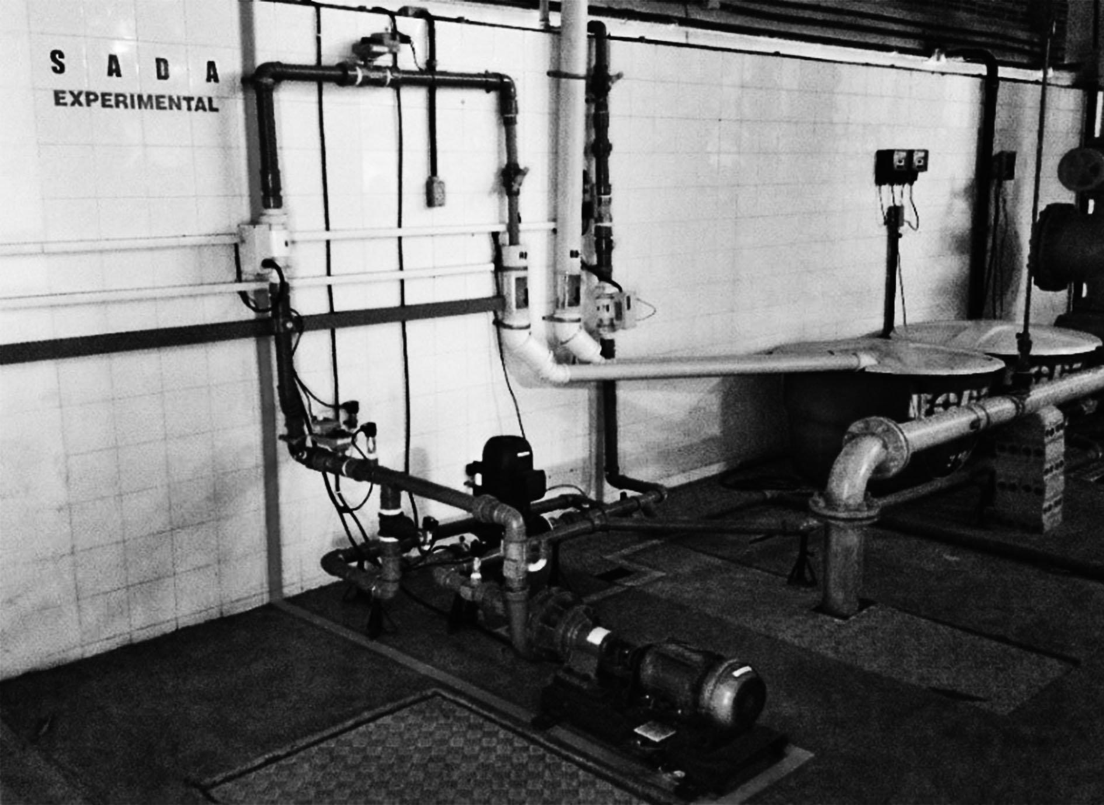
Figure I - Automated System of Water Distribution (ASWD)
Source: Salvino, 2015.

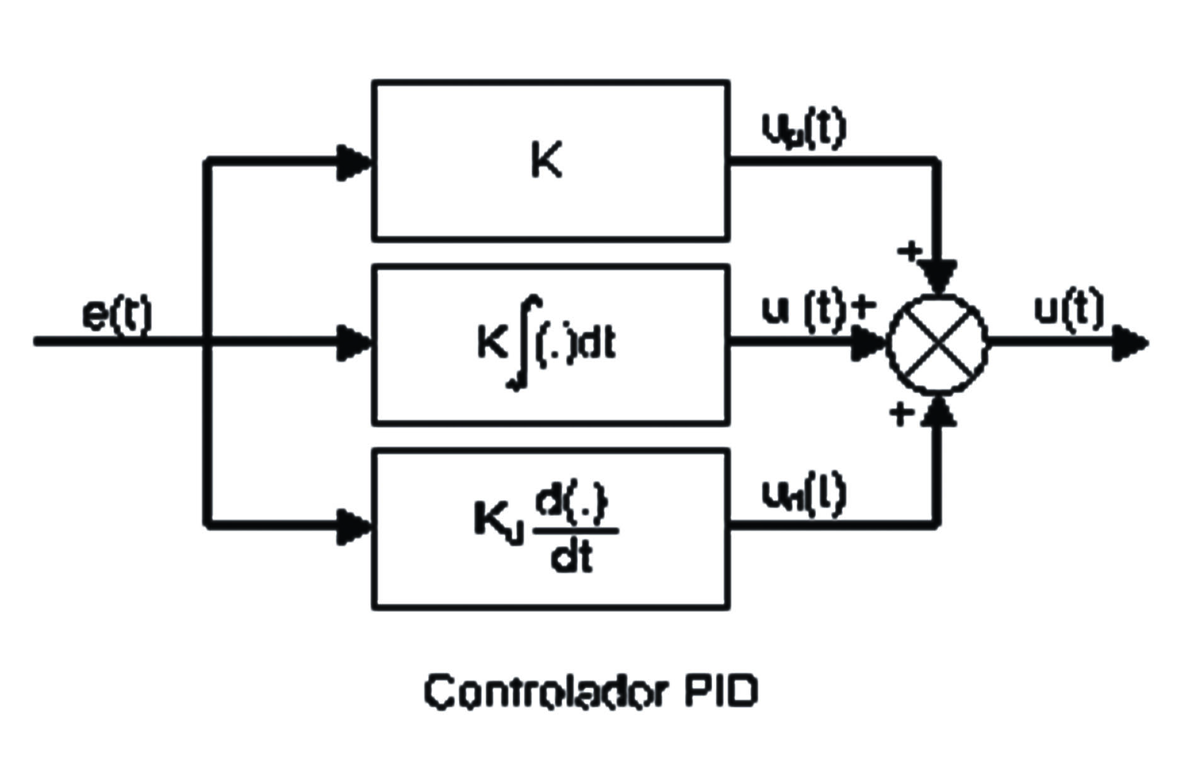
Figure II - 3D Model of the ASWD lower zone
Source: Negri, 2004.
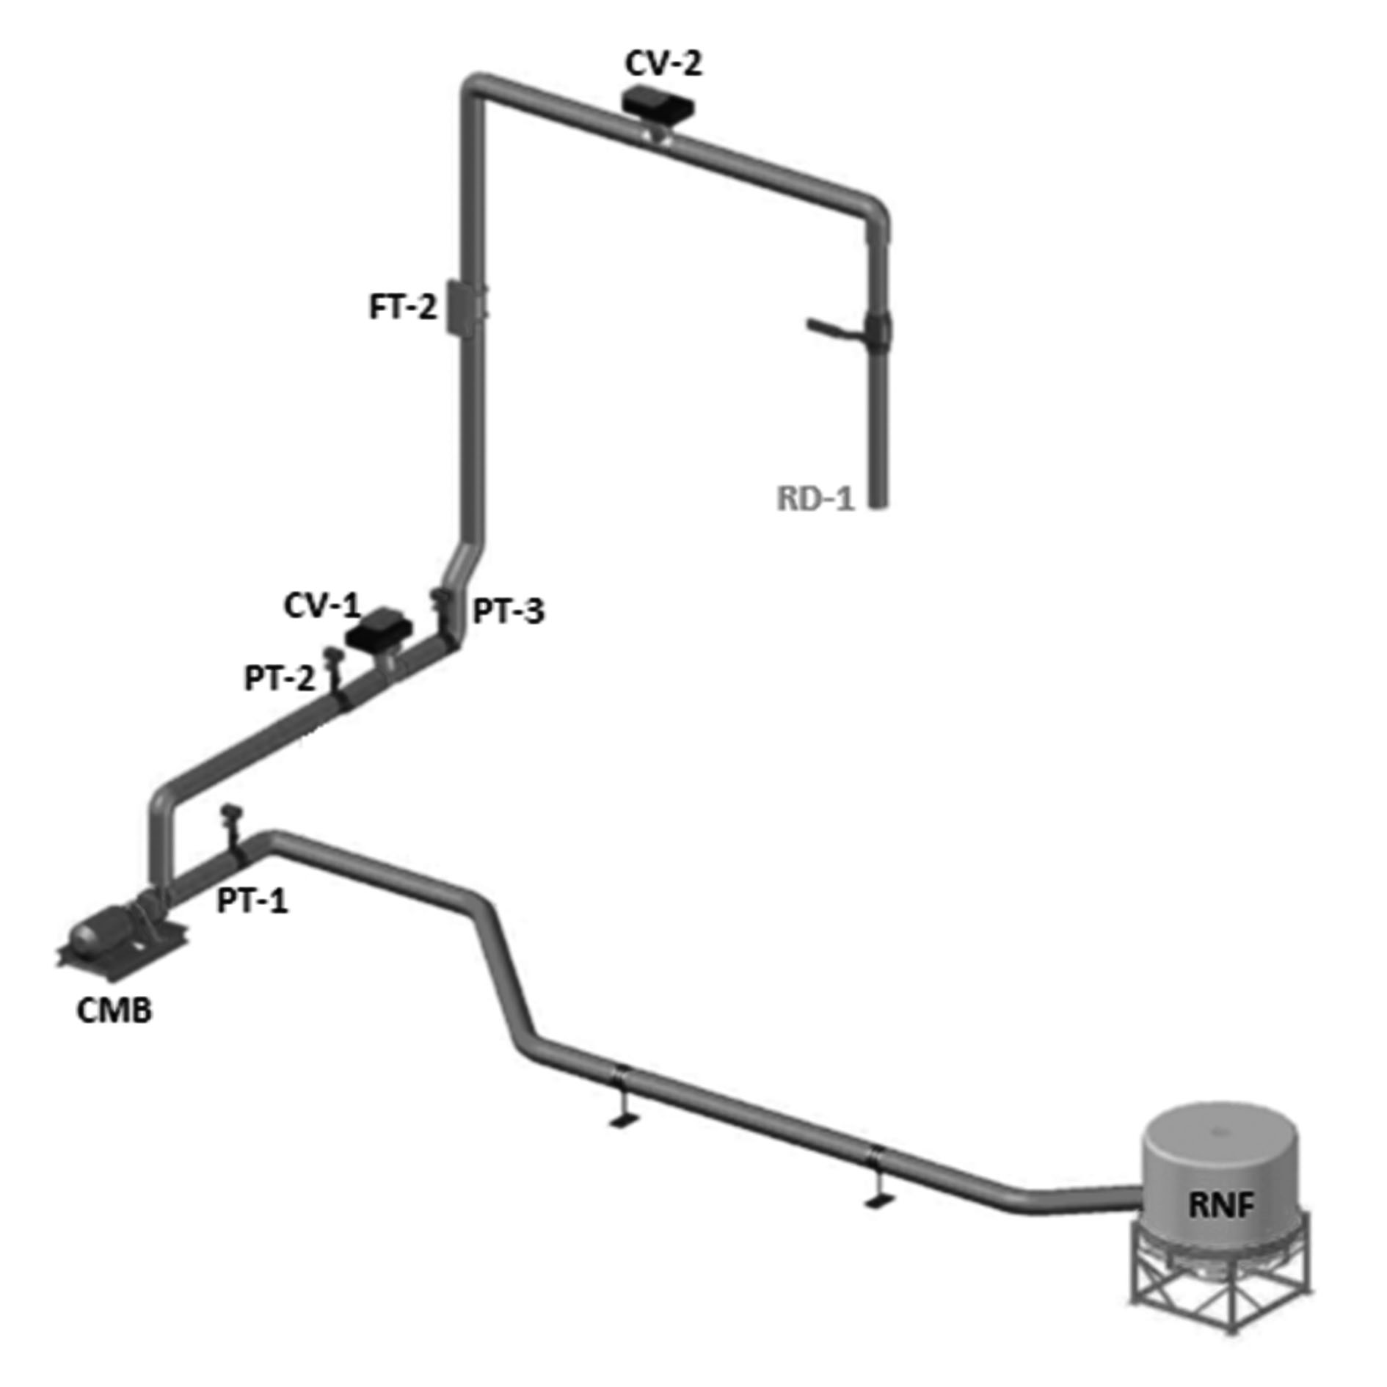
Figure III - Schematic illustration of a PID controller
Source: Salvino, 2015.
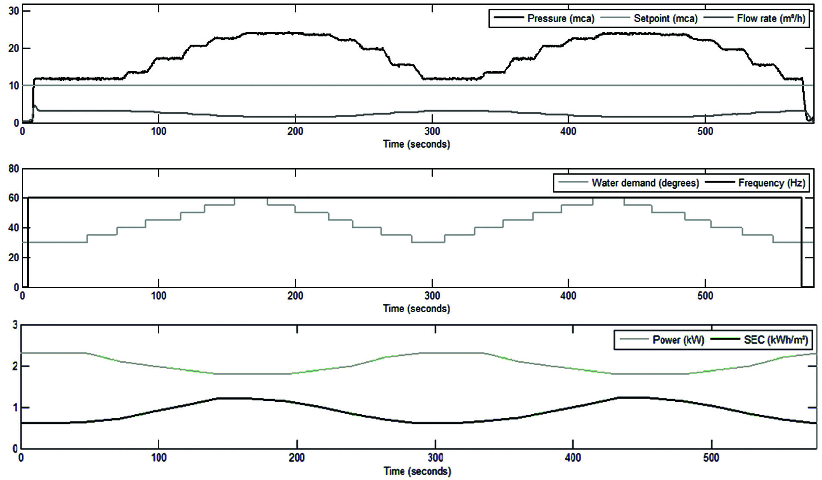
Figure IV - System operating without the action of the controller
Source: Salvino, 2015.

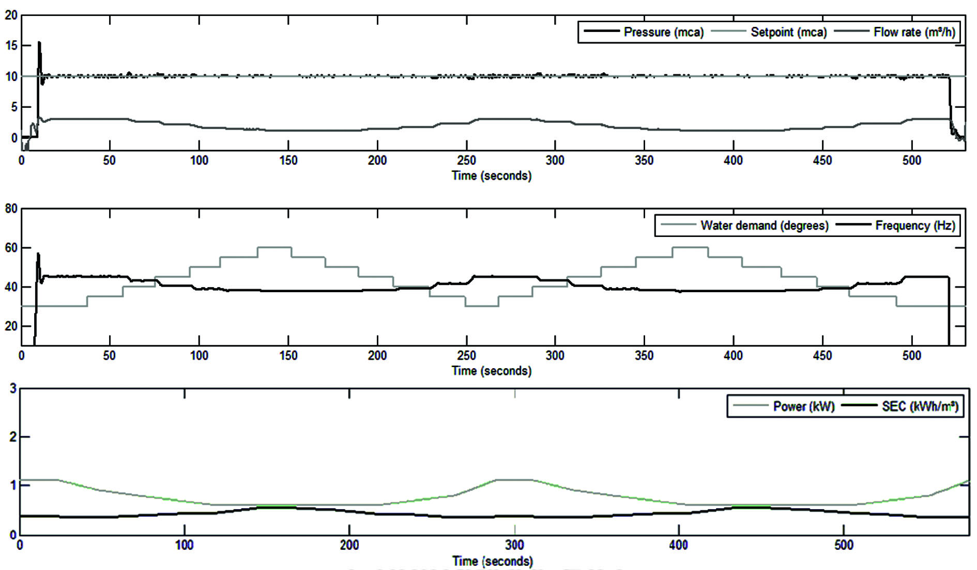

Figure V - System operating with the action of the PID controller
Source: Salvino, 2015.

