

Nov 1, 2016

MC. Gloria Magaña Cota
Editor
Acta Universitaria Multidisciplinary Scientific Journal
Universidad de Guanajuato
Lascuráin de Retana no. 5, Centro, C.P. 36000,
Guanajuato, Gto., México

Re: Thermal ecology of the Rattlesnake Crotalus catalinensis from Santa Catalina Island, Golf de California
Arnaud Gustavo, Sarahi Sandoval, Jonathan G. Escobar-Flores, Jose L. Burguete

We would like to submit to review the article: “Thermal ecology of the Rattlesnake Crotalus catalinensis from Santa Catalina Island, Golf de California”, in order to be publicated in the prestigious journal Acta Universitaria Multidisciplinary Scientific Journal. Thank you in advance for your attention.

Yours sincerely

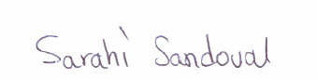

Dr. Sarahi Sandoval Espinoza
Corresponding Author
Instituto Politécnico Nacional, CIIDIR Unidad Durango
Durango, Durango 34220, México.
Email: ssandoval@conacyt.mx

